Fierte Multi-Academy Trust Calculation policy – division
Key language: divided by, share, divisible by, share equally, group, divide into
Concrete | Pictorial | Abstract
Sharing using a range of objects  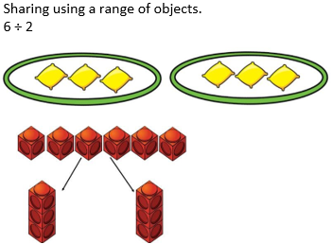  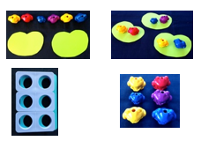  Grouping using an array.  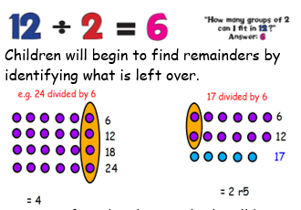 | 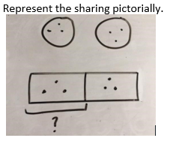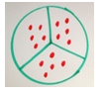 | 6÷ 2 = 3  6÷3=2
  6
  3 | 3
  6
  2 | 2 | 2
Place Cuisenaire rods above a ruler or number tracks.  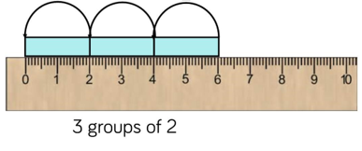 | 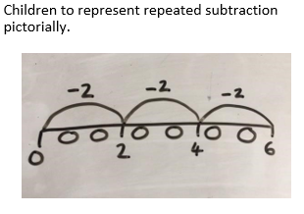  Number line to represent the equal groups we have divided.  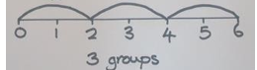 | 6÷2=3  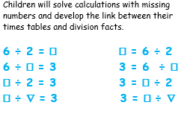
Dividing with remainders using lollipops sticks. Cuisenaire rods, above a ruler can also be used.  13÷4  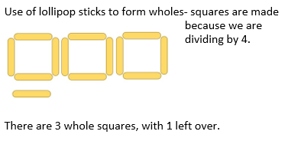 | 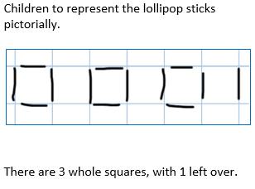 | 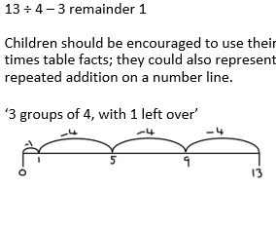
Sharing using place value counters  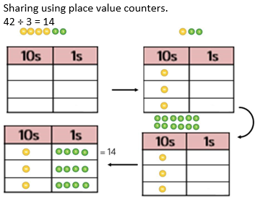  Short division using place value counters to group.  615 ÷ 5  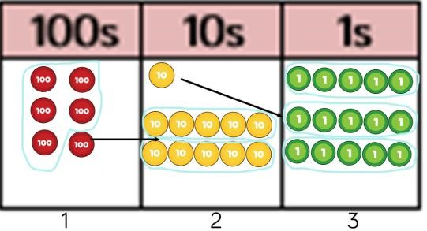  - Make 615 with place value counters.  - How many groups of 5 hundreds can you make with 6 hundred counters?  - Exchange 1 hundred for 10 tens.  - How many groups of 5 tens can you make with 11 ten counters?  - Exchange 1 ten for 10 ones.  - How many groups of 5 ones can you make with 15 ones? | 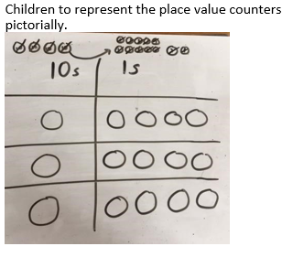  Represent the place value counters pictorially.  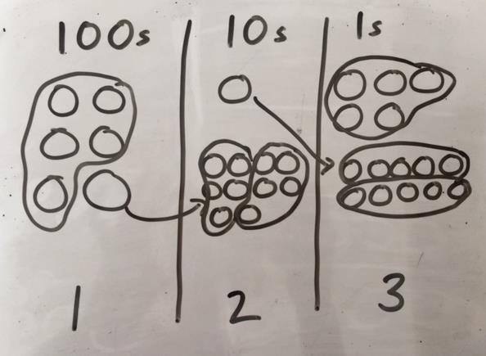 | Children to be able to make sense of the place value counters and write calculations to show the process.  42 ÷ 3  42 = 30 + 12  30 ÷ 3 = 10  12 ÷ 3 = 4  10 + 4 = 14  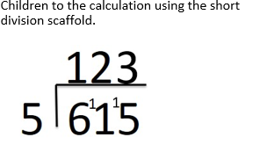  Children will be able to calculate division facts for multiples of 10 by using associated facts.  30 ÷ 6 = 5  30 ÷ 5 = 6  300 ÷ 6 = 50  300 ÷ 5 = 60  Using this knowledge they will be able to mentally chunk larger numbers once their number skills are well developed and secure.
Long division using place value counters  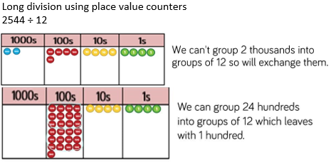 | 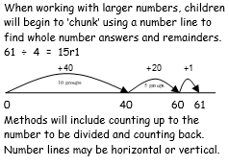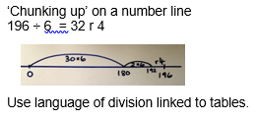 | 

