Fierte Multi-Academy Trust Calculation policy – Subtraction
Key language- subtract, take away, minus, decrease, leave, how many are left/left over? Difference between, how many fewer is.. than...?, how much less is...?
Concrete | Pictorial | Abstract
Physically taking away and removing objects from a whole (ten frames, Numicon, cubes and other items such as beanbags could be used).  4 – 3 = 1  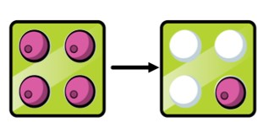  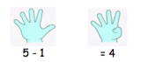  Real life links will also be made e.g. taking biscuits off a plate. | Children to draw the concrete resources they are using and cross out the correct amount. The bar model can also be used.  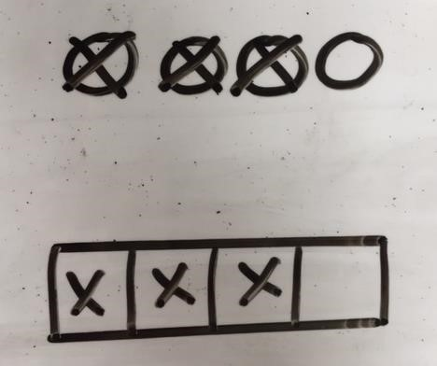 | 4- 3 =  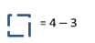  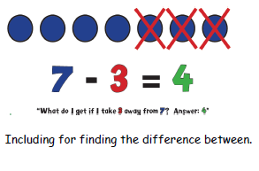
Counting back (using number lines or number tracks) children start with 6 and count back 2.  6 – 2 = 4  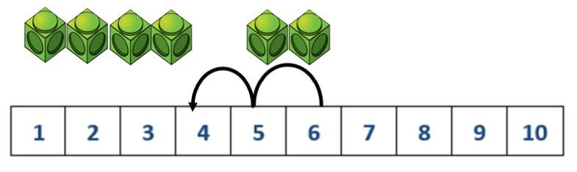  Children will count backwards along a number line using finger.  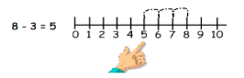  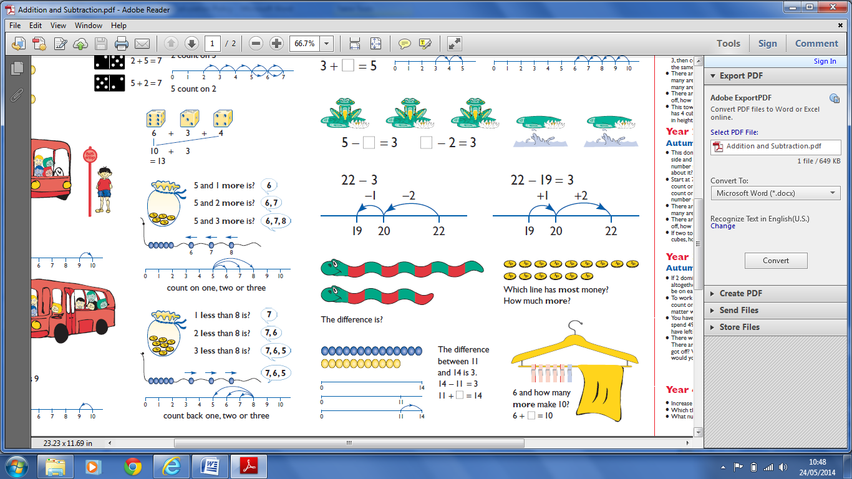  Progressing to: | Children to represent what they see pictorially on a number line or number track and show their jumps. Encourage children to use an empty number line  e.g.  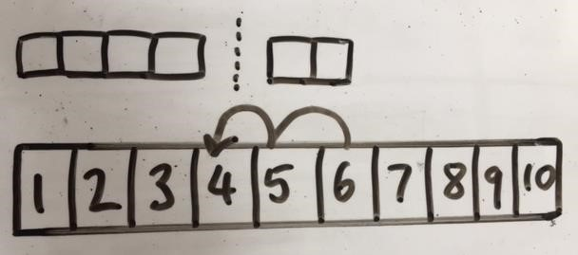  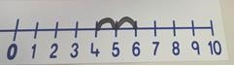  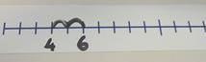  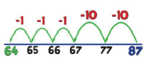 | 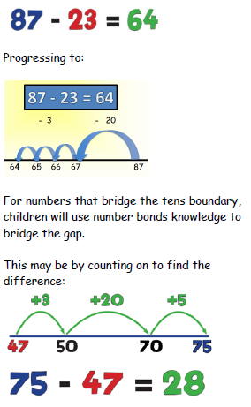
Finding the difference (using cubes, Numicon or Cuisenaire rods, other objects can also be used).  Calculate the difference between 8 and 5.  Children will understand subtraction as finding the difference between 2 numbers, either by counting back or counting on. 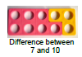  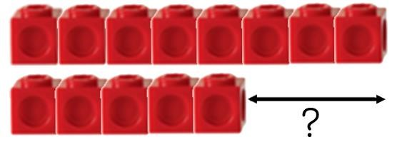  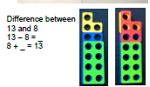 | Children to draw the cubes/other concrete objects which they have used or use the bar model to illustrate what they need to calculate.  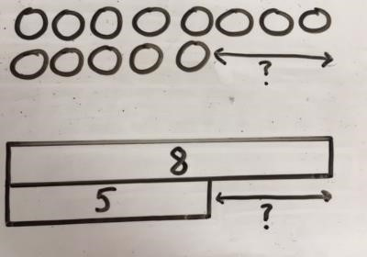 | Find the difference between 8 and 5.  8– 5, the difference is  Children to explore why  9- 6 = 8 – 5 = 7 – 4 have the same difference.
Making 10 using ten frames.  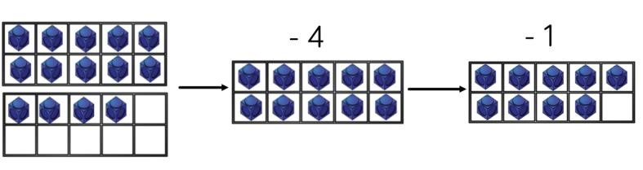  14 – 5 | 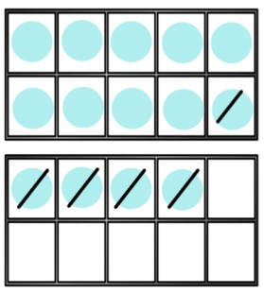  Children to present the ten frame pictorially and discuss what they did to make 10. | Children to show how they can make 10 by partitioning the subtrahend.  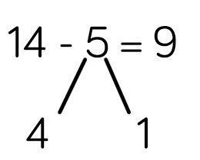  14 – 4 = 10  10 – 1 = 9
Column method using base 10.  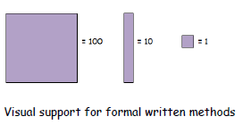  48-7=  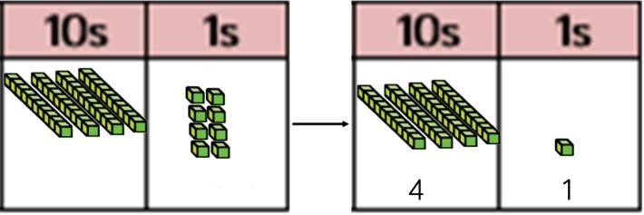  This will be supported by equipment, starting from the biggest number and removing the tens and ones to show what is left.  78 - 46 = 32  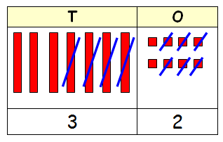 | Children to represent the base 10 pictorially.  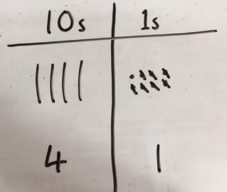 | Column method or children could count back 7.  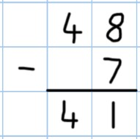  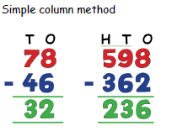

Column method using base 10 and having to exchange.  Using visual methods will help to secure key concepts and also enable children to use equipment. Pictures can later be replaced with numbers once the children have gained a secure understanding 41 – 26  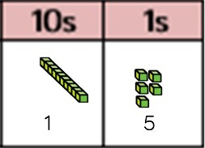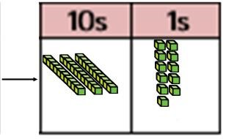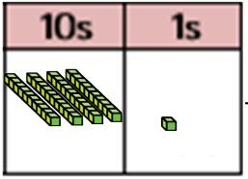. 72 - 48 = 24  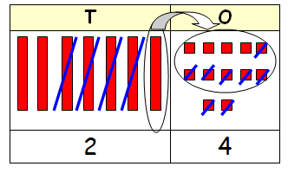  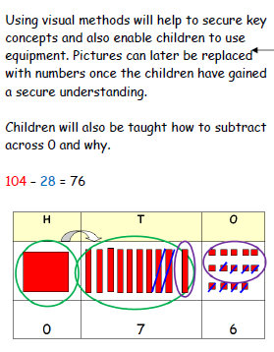 | Represent the base 10 pictorially, remembering to show the exchange.  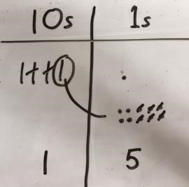 | Formal column method. Children must understand that when they have exchanged the 10 they still have 41 because 41 = 30 + 11.  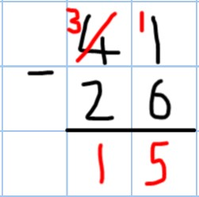  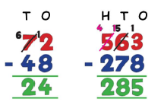
Using place value counters to subtract  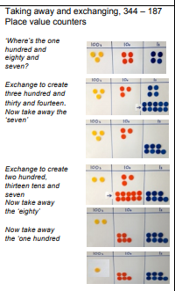 | 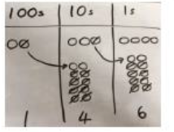  Represent the place value counters pictorially remembering to show what has been exchanged. | Formal column method. Children must understand what has happened when they cross out digits.
  100  200 | $$120$$  20  30 | 1  4
   | 80 | 8
  100 | 40 | 6

