Music development plan summary:
Wilnecote Junior School

Overview
Detail | Information
Academic year that this summary covers | 23/24
Date this summary was published | June 24
Date this summary will be reviewed | July 25
Name of the school music lead | Sara Kimber
Name of school leadership team member with responsibility for music (if different) | N/A
Name of local music hub | Entrust Music Service
Name of other music education organisation(s) (if partnership in place) | K Caddy Piano Teaching

This is a summary of how our school delivers music education to all our pupils across three areas – curriculum music, co-curricular provision and musical experiences – and what changes we are planning in future years. This information is to help pupils and parents or carers understand what our school offers and who we work with to support our pupils’ music education.

Part A: Curriculum music
This is about what we teach in lesson time, how much time is spent teaching music and any music qualifications or awards that pupils can achieve.
At Wilnecote Junior Academy the music curriculum at Key Stage 2 reflects the importance of these school years in terms of music progression. The key skills and techniques taught will build on those introduced at Key Stage 1 as shown in the progression document and prepare pupils for progression to Key Stage 3.
At Wilnecote Junior Academy our focus is singing and musicianship. This is developed throughout the year groups and with supported curriculum from instrumental work throughout.
This development of children to progress is supported by the year 6 curriculum which contains a large amount of KS3 skills and it has been commented on that our children show excellent musicianship as they move into secondary school.
Through a wide range of activities, pupils will further develop their love of music, refining their individual taste and gaining confidence to be creative musicians with strong aural skills. They will encounter music by living composers and see composition as a current art form. Repetition of techniques is vital to consolidate and gain confidence, and songs, chants and listening repertoire are suggested as a starting point. Pupils will continue to internalise key musical skills and techniques through a range of activities including call-and-response songs and chants, improvisation, movement and active listening.
Pupils will create music through improvisation, exploring how to write music for a specific purpose, and they will start to learn more sophisticated compositional techniques and structures to prepare for Key Stage 3. Notation is introduced in various forma and moves on to staff notation. Pupils will build musical confidence through active engagement with music as performers, music-creators and audience.
We ensure children are ‘doing music’ regularly in lessons, assemblies and concerts. The pupils regularly perform with our music specialist and other musicians both inside and outside school, and develop an understanding of the excellence and dedication needed to become an accomplished musician. Pupils will further develop their shared knowledge of important moments in the evolution of music and of key musicians, including composers and performers, in a range of genres and styles. The history of music will be explored in a variety of ways, placing music in artistic, historical, social and political contexts, and building meaningful and memorable connections.

Here is a list of general outcomes that can be applied throughout the plans and within lessons;
- Memorise repertoire
- Tunefully sing whilst performing the beat
- Inner-hear known songs and rhythmic and melodic motifs
- Sing selected songs and clap the rhythm
- Sing selected songs and point to the melodic contour
- Aurally identify the beat on which a new rhythmic sound occurs.
- Aurally identify the beat on which a new melodic phrase occurs.
- Create a visual representation of a target phrase containing a new element.
- Label a rhythmic motif with rhythm syllables.
- Label a rhythmic motif with solfege syllables and hand signs.
- Write known rhythms using stick notation.
- Write rhythmic motifs of known songs using traditional notation.
- Write rhythmic motifs of unknown songs with stick notation.
- Write rhythmic motifs of unknown sings using traditional notation.
- Write melodic motifs of known songs using traditional rhythmic notation with solfege syllables beneath or on the staff.
- Write melodic motifs of unknown songs using traditional rhythmic notation with solfege syllables beneath or on the staff.
- Sing selected songs using rhythm syllables.
- Sing selected songs using solfege syllables and hand signs.
- Read the rhythm of known songs written in traditional rhythmic notation with rhythm syllables.
- Read the melody of known songs written in traditional notation with solfege syllables beneath as well as staff notation using solfege syllables and hand signs.
- Read new songs written in traditional notation with solfege syllables beneath as well as staff notation with solfege syllables and hand signs.
- Improvise and compose music with the newly learned musical element to a given form.
- Improvise/compose an ostinato using the new element to accompany a known song.
- Improvise/compose a new ostinato and play it on a classroom instruments to accompany a known song.
- Improvise/compose new words for a known song.
- Create a new melody for a known song text.
- Identify known rhythmic or melodic elements in listening examples.
- Identify the form of known and unknown music compositions.
- Memorise rhythmic or melodic motifs.
- Memorise unison melodies.
- Memorise two-part examples.
- Develop part-work skills.
- Identify known rhythmic and melodic elements in a listening example.
- Identify the form of a listening example.
Our main thread of musical development throughout is
musicianship through singing.
Year 3 (percussion, recorders and singing)
Sing a widening range of unison songs of varying styles and structures with a pitch range of do–so tunefully and with expression.
Performance
Perform forte and piano, loud and soft.
• Perform actions confidently and in time to a range of action songs (e.g. Heads and Shoulders).
• Walk, move or clap a steady beat with others, changing the speed of the beat as the tempo of the music changes.
• Perform as a choir in school assemblies.
Listening
The teaching and learning of music is enriched by developing pupils’ shared knowledge and understanding of the stories, origins, traditions, history and social context of the music they are listening to, singing and playing. Listening to recorded performances should be complemented by opportunities to experience live music making in and out of school.
Improvise
• Become more skilled in improvising (using voices, tuned and untuned percussion and instruments played in whole-class/group/individual/instrumental teaching), inventing short ‘on-the-spot’ responses using a limited note-range
• Structure musical ideas (e.g. using echo or question and answer phrases) to create music that has a beginning, middle and end. Pupils should compose in response to different stimuli, e.g. stories, verse, images (paintings and photographs) and musical sources.
Compose
• Combine known rhythmic notation with letter names to create rising and falling phrases using just three notes (do, re and mi).
• Compose song accompaniments on untuned percussion using known rhythms and note values. Performing
• Develop facility in playing tuned percussion or a melodic instrument such as violin or recorder. Play and perform melodies following staff notation using a small range (e.g. Middle C–E/do–mi) as a whole class or in small groups (e.g. trios and quartets).
• Use listening skills to correctly order phrases using dot notation, showing different arrangements of notes C-D-E/do-re-mi.
• Individually (solo) copy stepwise melodic phrases with accuracy at different speeds; allegro and adagio, fast and slow. Extend to question-and-answer phrases.
Reading Notation
• Introduce the stave, lines and spaces, and clef. Use dot notation to show higher or lower pitch.
• Introduce and understand the differences between crotchets and paired quavers.
• Apply word chants to rhythms, understanding how to link each syllable to one musical note.

Year 4 (glockenspiel, violins and singing)
Singing
• Continue to sing a broad range of unison songs with the range of an octave (do–do pitching the voice accurately and following directions for getting louder (crescendo) and quieter (decrescendo).
• Sing rounds and partner songs in different time signatures (2, 3 and 4 time) and begin to sing repertoire with small and large leaps as well as a simple second part to introduce vocal harmony
• Perform a range of songs in school assemblies.
• Copy short melodic phrases including those using the pentatonic scale (e.g. C, D, E, G, A).
Listening
The teaching of music is enriched by developing pupils’ shared knowledge and understanding of the stories, origins, traditions, history and social context of the music they are listening to, singing and playing. Listening to recorded performances should be complemented by opportunities to experience live music making in and out of school.
Improvise
• Improvise on a limited range of pitches on the instrument they are now learning, making use of musical features including smooth (legato) and detached (staccato).
• Begin to make compositional decisions about the overall structure of improvisations. Continue this process in the composition tasks below.
Compose
• Combine known rhythmic notation with letter names to create short pentatonic phrases using a limited range of 5 pitches suitable for the instruments being learnt. Sing and play these phrases as self-standing compositions.
• Arrange individual notation cards of known note values (i.e. minim, crotchet, crotchet rest and paired quavers) to create sequences of 2-, 3- or 4-beat phrases, arranged into bars.
• Explore developing knowledge of musical components by composing music to create a specific mood, for example creating music to accompany a short film clip.
• Introduce major and minor chords.
• Include instruments played in whole-class/group/individual teaching to expand the scope and range of the sound palette available for composition work.
• Capture and record creative ideas using any of:
o graphic symbols
o rhythm notation and time signatures
o staff notation o technology.
Performing Instrumental Performance
• Develop facility in the basic skills on the violin over a sustained learning period. Following the whole class teaching.
• Play and perform melodies following staff notation using a small range (e.g. Middle C–G/do–so) as a whole-class or in small groups.
• Perform in two or more parts (e.g. melody and accompaniment or a duet) from simple notation using instruments played in whole class teaching. Identify static and moving parts. 27
Reading Notation
• Introduce and understand the differences between minims, crotchets, paired quavers and rests.
• Read and perform pitch notation within a defined range (e.g. C–G/do–so).
• Follow and perform simple rhythmic scores to a steady beat: maintain individual parts accurately within the rhythmic texture, achieving a sense of ensemble.

Year 5 (keyboard instruments, guitars and singing) children can use the instrument that they have lessons on instead
Singing
• Sing a broad range of songs from an extended repertoire with a sense of ensemble and performance. This should include observing phrasing, accurate pitching and appropriate style.
• Sing three-part rounds, partner songs, and songs with a verse and a chorus.
• Perform a range of songs in school assemblies and in school performance opportunities.
Listening
The teaching of music is enriched by developing pupils’ shared knowledge and understanding of the stories, origins, traditions, history and social context of the music they are listening to, singing and playing. Listening to recorded performances will be complemented by opportunities to experience live music making in and out of school.
Composing Improvise
• Improvise freely over a drone, developing sense of shape and character, using tuned percussion and melodic instruments.
• Improvise over a simple groove, responding to the beat, creating a satisfying melodic shape; experiment with using a wider range of dynamics, including very loud (fortissimo), very quiet (pianissimo), moderately loud (mezzo forte), and moderately quiet (mezzo piano).
Continue this process in the composition tasks below.
Compose
• Compose melodies made from pairs of phrases in either C major or A minor or a key suitable for the instrument chosen. These melodies can be enhanced with rhythmic or chordal accompaniment.
• Working in pairs, compose a short ternary piece.
• Use chords to compose music to evoke a specific atmosphere, mood or environment, and compose music from a specific stimulus.
• Capture and record creative ideas using any of: o graphic symbols o rhythm notation and time signatures o staff notation o technology. * Includes names of countries or regions, where the origin of a piece cannot be attributed to one single country.
Performing
Instrumental Performance
• Play melodies on tuned percussion, melodic instruments or keyboards, following staff notation written on one stave and using notes within the Middle C–C′/do–do range.
• Understand how triads are formed, and play them on tuned percussion, melodic instruments or keyboards. Perform simple, chordal accompaniments to familiar songs (e.g. Yellow Submarine by The Beatles).
• Perform a range of repertoire pieces and arrangements combining acoustic instruments to form mixed ensembles, including a school orchestra.
• Develop the skill of playing by ear on tuned instruments, copying longer phrases and familiar melodies.
Reading Notation
• Further understand the differences between semibreves, minims, crotchets and crotchet rests, paired quavers and semiquavers.
• Understand the differences between 2/4, 3/4 and 4/4 time signatures.
• Read and perform pitch notation within an octave (e.g. C–C′/do–do).
• Read and play short rhythmic phrases at sight from prepared cards, using conventional symbols for known rhythms and note durations.

Year 6 (keyboard instruments, guitars and singing) children can use the instrument that they have lessons on instead
Singing
• Sing a broad range of songs, including those that involve syncopated rhythms, as part of a choir, with a sense of ensemble and performance. This should include observing rhythm, phrasing, accurate pitching and appropriate style.
• Continue to sing three- and four-part rounds or partner songs, and experiment with positioning singers randomly within the group – i.e. no longer in discrete parts – in order to develop greater listening skills, balance between parts and vocal independence.
• Perform a range of songs as a choir in school assemblies, school performance opportunities and to a wider audience.
Listening
The teaching and learning of music is enriched by developing pupils’ knowledge and understanding of the stories, origins, traditions, history and social context of the music they are listening to, singing and playing. Listening to recorded performances will be complemented by opportunities to experience live music making in and out of school.
Composing
Improvise Extend improvisation skills through working in small groups to:
• Create music with multiple sections that include repetition and contrast.
• Use chord changes as part of an improvised sequence.
• Extend improvised melodies beyond 8 beats over a fixed groove, creating a satisfying melodic shape. Compose
• Plan and compose an 8- or 16-beat melodic phrase and incorporate rhythmic variety and interest. Play this melody on available tuned percussion and/or orchestral instruments. Notate this melody.
• Compose melodies made from pairs of phrases in either G major or E minor or a key suitable for the instrument chosen.
• Either of these melodies can be enhanced with rhythmic or chordal accompaniment.
• Compose a ternary piece; use available music software/apps to create and record it, discussing how musical contrasts are achieved. * Includes names of countries or regions, where the origin of a piece cannot be attributed to one single country.
Performing
Instrumental Performance
• Play a melody following staff notation written on one stave and using notes within an octave range (do–do); make decisions about dynamic range, including very loud (ff), very quiet (pp), moderately loud (mf) and moderately quiet (mp).
• Accompany this same melody, and others, using block chords or a bass line. This could be done using keyboards, tuned percussion or tablets, or demonstrated at the board using an online keyboard.
• Engage with others through ensemble playing (e.g. school orchestra, band, mixed ensemble) with pupils taking on melody or accompaniment roles. The accompaniment, if instrumental, could be chords or a single-note bass line.
Reading Notation
• Further understand the differences between semibreves, minims, crotchets, quavers and semiquavers, and their equivalent rests.
• Further develop the skills to read and perform pitch notation within an octave (e.g. C–C/ do–do).
• Read and play confidently from rhythm notation cards and rhythmic scores in up to 4 parts that contain known rhythms and note durations.
• Read and play from notation a four-bar phrase, confidently identifying note names and durations.

SEND Music Support SOUNDS OF INTENT
As part of our SEND support we use Sounds of Intent. This is devised for children with complex needs and profound learning difficulties, however they work well with children who need focus and specific tasks in order for them to engage including the Autism spectrum. We use the ‘Tuning In’ music book and the ‘Tuning In’ cards to support TA’s and children to create activities for them to access the curriculum which can also be used in whole class settings too.
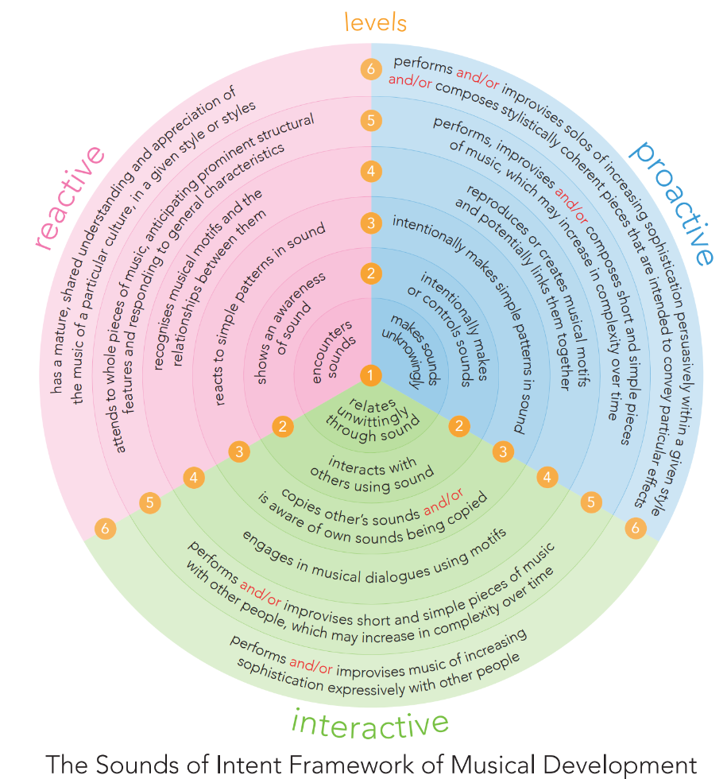

Part B: Co-curricular music
This is about opportunities for pupils to sing and play music, outside of lesson time, including choirs, ensembles and bands, and how pupils can make progress in music beyond the core curriculum.
PERIPATETIC MUSIC
We offer;
Violin
Guitar
Saxophone
Clarinet
Flute
Piano
We use Access for Young Musicians who support lessons for LAC children for free.
We also access FOSYM which is a Staffordshire Charity that provides funding and support for lessons/music/instruments particularly for PP children but also those who fall close to that line.
GROUPS WITHIN SCHOOL
School Orchestra free for everyone as all children learn instruments in classroom.
Performing Arts Group free for everyone
OUTSIDE OF SCHOOL
We have children who are;
attending the hubs Tamworth Music Centre on Saturdays, free for everyone
Members of Birmingham Junior Conservatoire.
Multiple finalists in Staffordshire Young Musician free but need to qualify through the opening rounds.
Members of the Staffordshire County Wind Band free for everyone
Members of the Staffordshire County String Ensemble free for everyone
Members of the Tamworth Music Centre Choir free for everyone (without lessons needed)
Members of the Tamworth Music Centre Junior Strings free for everyone (without lessons needed)
Members of the Tamworth Music Centre Junior Winds free for everyone(without lessons needed)
Members of the Tamworth Music Centre Youth Orchestra free for everyone
All children across school are given the opportunity to join these and be given a free instrument.
We take part in the Staffordshire Sings Christmas with over 10,000 other children and The Staffordshire Sings Summer Celebration, this includes the whole school.
We took part in the Staffordshire Recorder Festival at the Coton Centre with all of year 3.
We regularly have children entering for grade exams both with ABRSM and Trinity.
TEACHERS IN SCHOOL
Our music specialist works two days a week teaching all children a minimum of 40 mins in the classroom. We have a singing assembly where musicianship is the focus for 15 minutes.

Part C: Musical experiences
This is about all the other musical events and opportunities that we organise, such as singing in assembly, concerts and shows, and trips to professional concerts.
Every year group performs at least twice a year.
Every year group does a Christmas Concert for friends and parents (free)
Every year group does an Easter Concert for friends and parents (free)
Year 6 do a musical at the end on the academic year (free)
Each class has a class concert regularly throughout the year. Each child will perform at least twice and be audience when not performing.
Performing Arts Group perform 2 musicals a year (free)
School Orchestra perform regularly in singing assembly.
The top soloists perform at the high school at the end of the year (free)
All of year 3 went to a concert and watched and took part run by the hub (free)
We have links with Lichfield Cathedral and they come to visit and we go there to perform (usually a whole year group) (free)
Our music lead is an accomplished musician and leads by example, both in lessons and in assembly.

In the future
This is about what the school is planning for subsequent years.
Travelling to more live music concerts. Taking the whole school to a big music concert hall to take part and/or watch in a musical event…..plans in the pipeline.
Encourage another member for staff to run the school choir. We do create one for events but a regular one would be fabulous.
Making the musicianship assembly 20 mins to ensure everyone gets 1 hour with our specialist every week.
A brass peri to join the team.

Further information (optional)
The Local Music Hub Skills Progression Map
KS1-KS2-TMP-Musical-Skills-Progression-Document-2020-V2.pdf (entrustmusic.co.uk)
Entrusts Progress Framework for Peripatetic Lessons
Assessing-Musical-Progress-Framework.pdf (entrustmusic.co.uk)
Support for equal access to music provision including information about FOSYM
Supporting-Music-Across-Staffordshire.pdf (entrustmusic.co.uk)
Access to music lessons in school
Music-is-for-Everyone-Flyer.pdf (entrustmusic.co.uk)
The Department for Education publishes a guide for parents and young people on how they can get involved in music in and out of school, and where they can go to for support beyond the school.
The Fierte Trust plan will be added when availiable.

